“As unique individuals, we do our best at work and play for the love of God and others.”
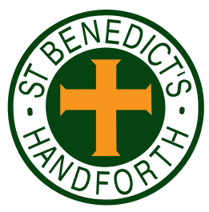

RE Newsletter Summer 2
Dear Parents,
We welcome you and your children back to school after the half term. We begin in the month of June which is dedicated to the Sacred Heart of Jesus. The devotion to the Sacred Heart of Jesus reminds us of the never ending and merciful love that Jesus has for us.

The Church’s prayer cycle for the summer includes the following:
- A Deeper Understanding between Christians and Jews.
- Those Who Suffer Persecution, Oppression and Denial of Human Rights, especially on Ss John Fisher and Thomas More (22 June)
- Europe, especially of the feasts of St Benedict (11 July), St Bridget of Sweden (23 July) who are Patrons of Europe
- Human Life, especially on Day for Life (3rd Sunday in June)
- Seafarers, especially on Sea Sunday (2nd Sunday in July)

We hope, as always, you find this newsletter interesting and informative. Please keep us in your prayers as we support your children in their Religious Education.

Dates from the Church’s calendar:
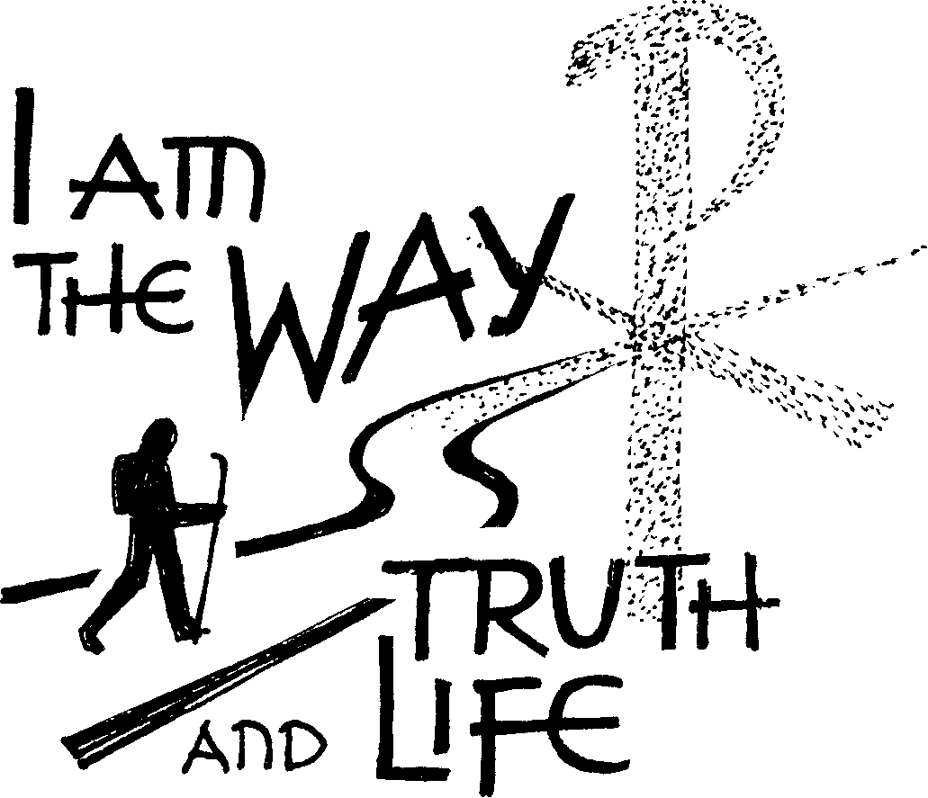
6th June Our Lady, Mother of the Church
8th June St William of York
11th June St Barnabas, Apostle
12th June Trinity Sunday
13th June St Anthony of Padua
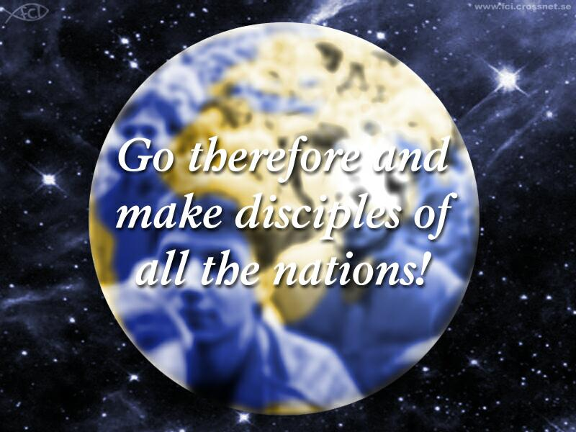
15th June Blessed Peter Snow
19th June Corpus Christi
20th June St Alban, Martyr
22nd June Ss John Fisher and Thomas More
23rd June Nativity of St John the Baptist
24th June Sacred Heart of Jesus
25th June Immaculate Heart of Mary
27th June Our Lady of Unfailing Help, Patron of the Diocese
29th June Ss Peter and Paul, Apostles
11th July St Benedict, Patron of Europe
23rd July St Bridget of Sweden, Patron of Europe

______________________________________________________

Reception— The Church
“The Church is the family of God, the people that God gathers in the whole world”
Religious Education Curriculum Directory
This half term, the children in the Nursery and the Reception classes will be learning about the Church. The children will begin to understand that we call the Church the family of God. They will learn that a church building is a holy place where we can all pray and are welcome. The children will learn that Jesus is present in a special way in the Blessed Sacrament and he invites us to be with him. They will learn to be thankful that lots of people help to look after the church and know why Sunday is a special day.
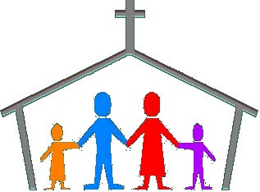
At home you could help your child by:
• visiting church, either for Mass or another time, to talk about the church
reminding them what a special place a Church is and reasons why
• talking to your child about their Baptism, explaining how this was the day
that they became part of God’s family.

________________________________
Year 1—Miracles
“The signs worked by Jesus attest that the Father has sent him. They invite belief in him. To those who turn to him in faith, he grants what they ask. So miracles strengthen faith in the One who does his Father’s works; they bear witness that he is the Son of God.”
Catechism of the Catholic Church
The children will hear some stories from the gospels which tell of Jesus using his God-given power to show his love and compassion. They will hear the story of the Calming of the Storm and know that we can ask Jesus to help us when we are afraid. They will learn that Jesus showed his love for sick people when he cured a man who was paralysed and know that Jesus has great love for people who are sick today. They will learn that Jesus responded to the faith of the blind man with compassion
and think of ways that we can trust Jesus in situations of need.


At home
You could help your child by:
•reading the story of the Calming of the Storm or other miracle stories from
the New Testament
▪talking to them about how we can ask Jesus, through our prayers, to help us

Year 2— The First Christians
“The Church is the family of God, the People that God gathers in the whole world. This Church is the communion of Christ’s disciples brought together in Christ its Head by the Holy Spirit. It is the Body of Christ, the Temple of the Spirit. As the People of God, the Church is drawn into Christ’s praise of the Father and Christ’s mission in the world. Religious Education Curriculum Directory

The children in Year 2 will learn that when the apostles received the Holy Spirit they spread the Good News. They will reflect on how they can spread the Good News. They will learn about the early Christian community and understand that the Christian community continues today to live by Baptism, the Eucharist and its mission to love God by loving our neighbour.
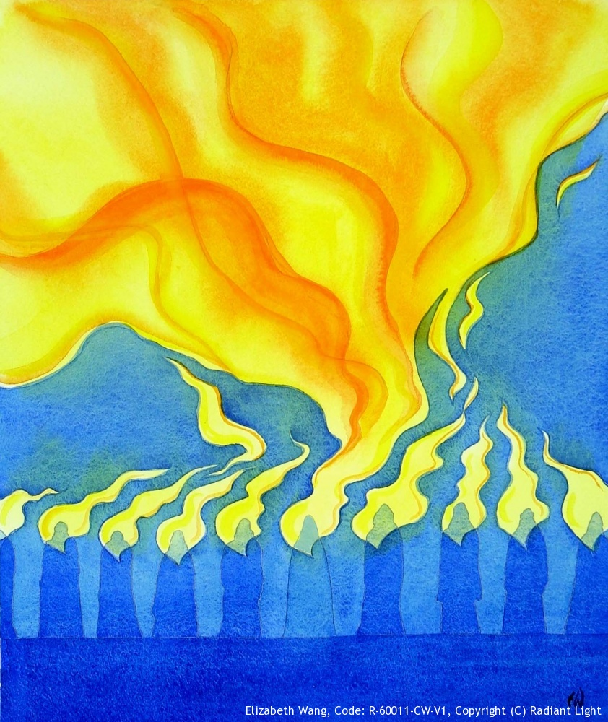

At Home
You could help your child by:

• talking about the symbols of the Holy Spirit and how the Spirit helps us

Year 3—Being a Christian
“The greatest commandment of all: “Listen Israel, the Lord your God is the one Lord, and you must love the Lord your God with all your heart, and with all your soul, with all your mind and with all your strength. The second is this: you must love your neighbour as yourself.” Mark 12: 29-30

“The truth of our union with Jesus Christ in the Eucharist is tested by whether or not we really love our fellow men and women.” Pope John Paul II, 1979

Year 3 will develop their understanding of what being a Christian involves. They will reflect on the joy and challenges involved in following Jesus and learn about these through the lives of Ss. Peter and Paul. The children will reflect on their gifts and talents and the gifts the Church calls Sacraments, especially the Eucharist. They will reflect on how to use the gifts God has given to us to be a
Christian .

At Home
You could help your child by:
• encouraging them to recognise their gifts and talents
• talk about how they can use their gifts and talents to help others

Year 4— The Church
“The Church is the family of God, the People that God gathers in the whole world. This Church is the communion of Christ’s disciples brought together in Christ its Head by the Holy Spirit. It is the Body of Christ, the Temple of the Spirit. As the People of God, the Church is drawn into Christ’s praise of the Father and Christ’s mission in the world.” Religious Education Curriculum Directory

Year 4 will learn that we all belong to a community. They will learn about different types of community and know what it means to belong to a community. They will develop their understanding of what it means to belong to community of the Church and know that people become a member of the Church through Baptism. The children will be introduced to the Creed – a statement of
the Catholic faith and learn about the structure of the Church’s liturgical year.

At Home:
You could help your child by:
• encouraging them to become an active member of the parish community

Year 5— Other Faiths
Nostra Aetate “All nations are one community and have one origin, because God caused the whole human race to dwell on the face of the earth. They also have one final end, God, whose providence, manifestation of goodness and plans for salvation are extended to all.”
Religious Education Curriculum Directory

Year 5 will learn about what we believe about our own Catholic faith. They will learn about some important Jewish beliefs and celebrations before thinking about the similarities and differences between their faith and people from the Jewish faith. The children will learn some significant Muslim beliefs and their important practices before thinking about the similarities and differences between the Muslim faith and their own.

At Home:
You could help your child by:
• talking to the children about their own faith
• research the Jewish and Muslim faiths.

Year 6 - Called to Serve
“The gifts of the Holy Spirit enable us to share the mission of the Church.”
Religious Education Curriculum Directory

The children will learn about Jesus’ teaching and example of service of others. They will develop their ability to recognise that God has given us all gifts and talents to use in the service of him and his people. They will learn about the gifts of the Holy Spirit and understand that we receive these gifts in a special way through the Sacrament of Confirmation.

The children will have an opportunity to:

• reflect on the Sacrament of Confirmation and the commitment
necessary of a Christian
• reflect on a life of service

At Home
You could help your children by:
• discussing the importance of the gifts of the Holy Spirit and the Sacrament of Confirmation
•discussing the many ways in which we can be called to serve God and our neighbour
▪ chatting about their gifts and talents, both obvious ones and hidden ones

